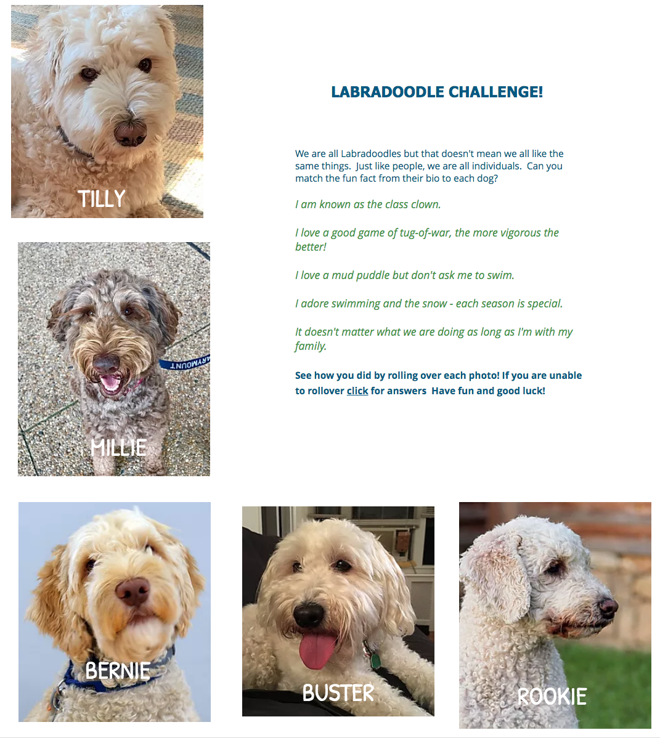
Dog’s Name/ Quote
Tilly: I adore swimming and the snow - each season is special.
Millie: It doesn't matter what we are doing as long as I'm with my family.
Bernie: I love a mud puddle but don't ask me to swim.

Buster: I am known as the class clown.
Rookie: I love a good game of tug-of-war, the more vigorous the better​!

