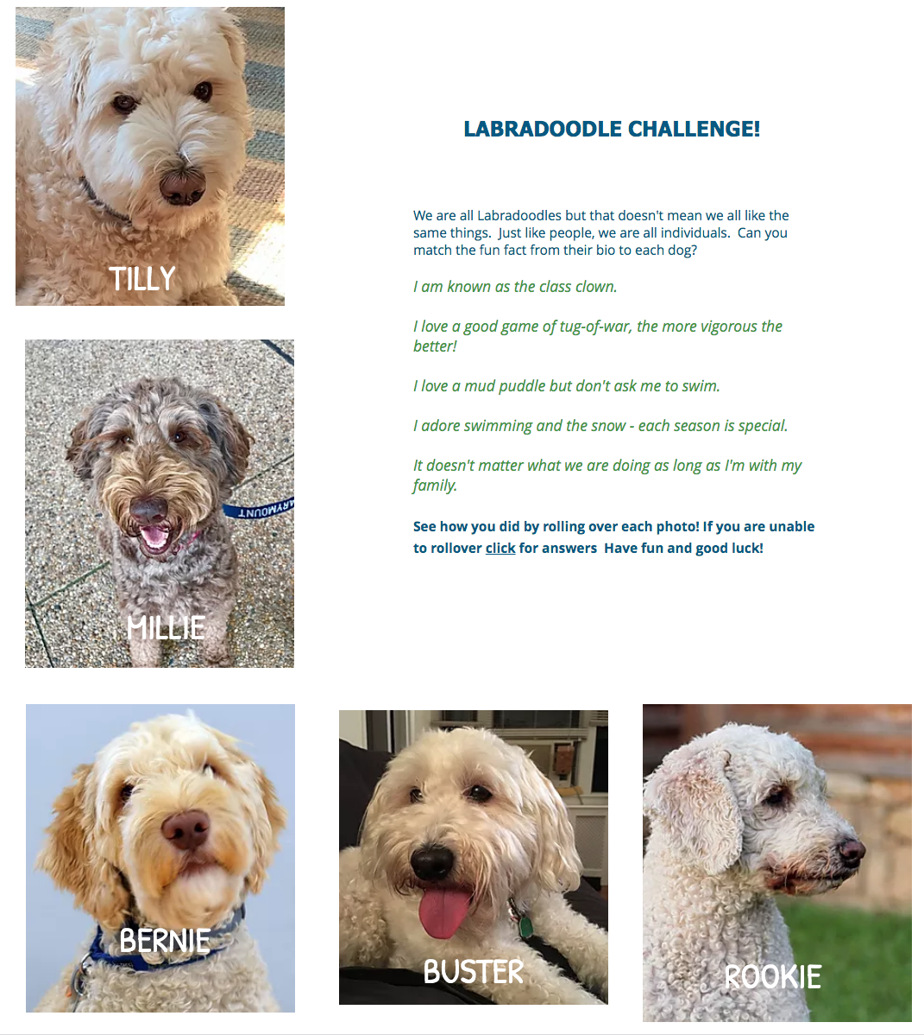
Dog’s Name/ Quote
Tilly: __________________________________________________________________________________

Millie: ___________________________________________________________________________________

Bernie: ___________________________________________________________________________________

Buster: ____________________________________________________________________________________

Rookie: ____________________________________________________________________________________

