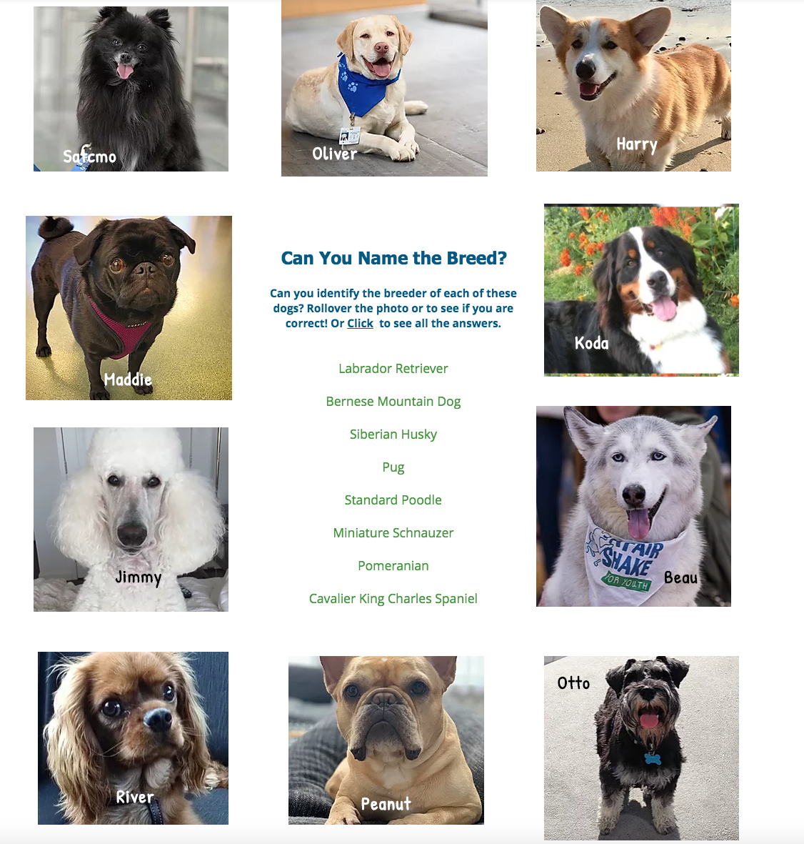

Dog Name / Breed
Satchmo: ____________________________ | Jimmy: ____________________________
Oliver: ____________________________ | Beau: ____________________________
Harry: ____________________________ | River: ____________________________
Maddie: ____________________________ | Peanut: ____________________________
Koda: ____________________________ | Otto: ____________________________

